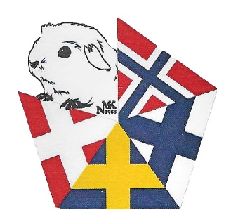
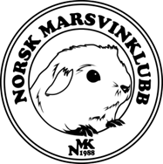
NMK INVITES YOU TO THE NORDIC CHAMPIONSHIP 2022

DATE: 10-11. SEPTEMBER 2022.
VENUE: Fossnes Grendehus, Skjelfossveien 89, 1827 Hobøl, NORWAY
Judges for Purebred:
* Eva Bednárová - Slovakia
* Daniel Dawid Banasiak - Poland
Judges Pet and Childrens Cavies:
* Anja Hamrin - Sweden
* Christina Rørbæk - Denmark
Deadline for signing up: 14. August – registration and payment after this date will not be accepted.
Please use our entry form in the link below or http://www.norskmarsvinklubb.no/paringmelding.html
Send to: karineelstad@gmail.com

A cavy can be shown in maximum 2 sections.The same cavy can not be shown i both Juvenile Pets and Pets.
Registration fees:
* Purebred 100 NOK
* Pet 100 NOK
* Juvenile Pets 100 NOK
* Breeders Groups 70 NOK

Payment:
* Paypal: karineelstad@gmail.com
* Account: 0540.08.47217.
IBAN: NO33 0540 0847 217, BIC (Swift-adresse) DNBANOKKXXX
Please write clearly on the transfer who the registration is for and that is is for the Nordic Championship.
Please note: Travel with animals to Norway. 3 guinea pigs pr person allowed. Cavies may not be brought to Norway in purpose to be sold. https://www.mattilsynet.no/dyr_og_dyrehold/reise_med_kjaledyr/fugler_gnagere_kaniner_til_Norge/
Arrival and Checking In: Friday from 18-21 and Saturday from 7:30-9-00
All cavies must be checked in also those under transit.
Norwegian rules for check in will apply. http://www.norskmarsvinklubb.no/uploads/2/3/3/2/23327806/utstillingsreglement.pdf
The cavies that are rejected during check-in will be placed, in brought cages/carriers that are at least 29x34cm in size with food and water available, in the quarantine room.
This is a cageless show. All cavies being shown must stay in their carriers (of at least 29x34cm in size, 3 rooms in an aluminium pigeon basket). There will be free bedding, hay and vegetables of good quality available. Food bowls, water bottles and pellets must be brought by owner. It is expected that everyone helps to keep the area around the cavies tidy and clean.
Cavies in transit must be in cages/carries of at least 29x34cm in size with food and water available in the transit Room.
All cavies must be present for both days until the show is over.
Children can show in the ‘Juvenile Pets’ category until and including the year they turn 15.
Membership: Anyone can show, but only members of DMK, DMF, SMF, NMK, NMF or SMY can compete for Nordic titles.
The Nordic countries will be competing against each other. The 10 best results for each country will be added up, and the country with the most points wins.

Nearby accommodation:
- Scandic Brennemoen | Hotel in Mysen | Scandic Hotels (33 km from the venue)
- Hotell i Ski | Thon Hotels (23 km from the venue)
- Overnatting | Vestby Hyttepark | Viken (19 km from the venue)
- Hotell | Storebaug Gjestegård | Viken (20 km from the venue)

There will be a kiosk at the venue selling food, coffe, tea, softdrinks.

Dinner and party:
Seperate invitation will be sent out before entries are closed.

Show manager:
Tom Erik Feragen

Any questions please contact:
Tom Erik Feragen: Tomerikferagen@hotmail.com
Karine Elstad: karineelstad@gmail.com.

